Name __________________________________
Groundwater Practice Problems

I = (H₂ –H₁ ) / L I = hydraulic gradient
V = D / T H₂ = height of water in well 2
V = (K I) / n hH₁ = height of water in well 1
K = (n V)/ I L = distance between well 1 and well 2
Q = K I A (Darcy’s Law) V = velocity
D = distance
T = time
K = permeability
n = porosity
Q = discharge
A = cross sectional area of aquifer (B x W)

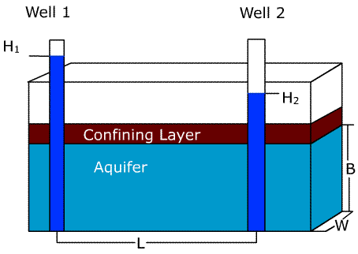

- Calculate hydraulic gradient if H₂ = 165 feet, H₁ = 150 feet, and L = 1005 feet.

I = __________

- Calculate velocity if D = 4 in and T = 760 sec.

V = __________ in/sec V = __________ ft/day

- Calculate permeability if porosity is 28%. (Use I and V from above) (1 ft = 30.48 cm)

K = __________ ft/day K = __________ cm/sec

- Calculate Q if A = 300 ft². (1 ft³ = 7.48 gallons)

Q = __________ ft³/day Q = _________ gallons/day

