SOIL NOTES

The Rock Cycle

IGNEOUS
ROCK

SEDIMENTARY
ROCK
METAMORPHIC
ROCK

What is soil?
The relatively thin surface layer of the Earth’s crust consisting of ________________________________________.
Soil is not _____________________!

5 Soil-Forming Factors
Formed from _______________________ (bedrock) that’s slowly broken down through _____________________.
- _________________________ (precipitation and temperature)
- _________________________ (macro- and microorganisms and plants)
- _________________________ (topography)
- _________________________ (rocks/minerals)
- _________________________
Which is the most important? _________________________________

Soil Composition
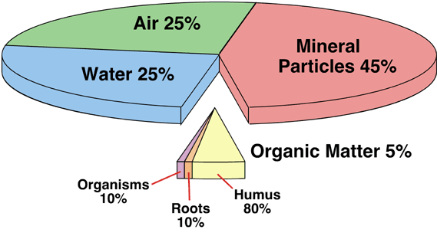

Mineral matter comes from ______________________________
Air and water percents are interchangeable
Organic matter includes ______________________ (the stable, long-lasting remnant of decaying organic material)
Mineral Matter:
Provides nutrient minerals for ____________________
Provides pore space for _________________________
Older soils are:
More _________________________
Lower in certain essential _______________________

Humus: ______________________________________________________________________________________

- _________________________, __________________________, and _________________________
- Increases the soil’s ______________________________ by acting like a sponge
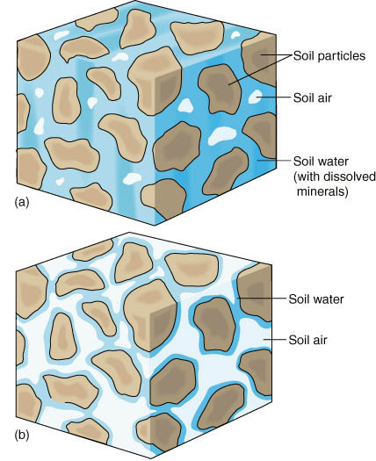
Porosity
Porosity = _______________________________

Pore spaces occupy _____% of a soil’s volume
Filled with varying proportions of ____________ and ____________

Soil air contains the same _______________ as __________________________ air, but in different proportions
- More _____and less _____ (from organism respiration)
- Some bacteria need ____________________
- The _____ can accelerate weathering (_____________________________(carbonic acid))

As _______________ infiltrates the soil, it can carry ________________________________________ with it

Leaching: _____________________________________________________________________________________

Illuviation: ____________________________________________________________________________________
Some substances completely leach out of the soil because they are so _______________ that they migrate right down to the ____________________

Soil Structure

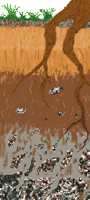

Soil Organisms
Ex: bacteria, fungi, algae, microscopic worms, protozoa, plant roots, insects, earthworms, moles, snakes, groundhogs, etc.
Soil organisms provide several _____________________________ (important environmental functions).
- __________________________________________________
- __________________________________________________
- __________________________________________________
- __________________________________________________
- __________________________________________________
Earthworms & Ants:
- __________________________________________________
- __________________________________________________
- __________________________________________________
- __________________________________________________
Mycorrhizae
- _____________________________ between fungi and the roots of vascular plants
- ___________________________________________________ from the soil, and provides it for the plant.
- _______________________________________________ (photosynthesis), and provides it for the fungus.

Physical Soil Properties
- ______________________________
- ______________________________ and _________________________
- ______________________________

Texture
- Determined by percent _______________, _______________, _______________
- Determines the _________________________ and the ______________________________
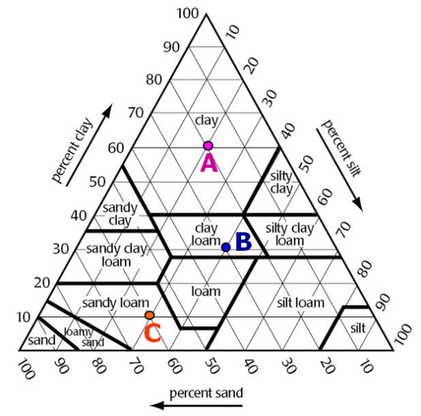
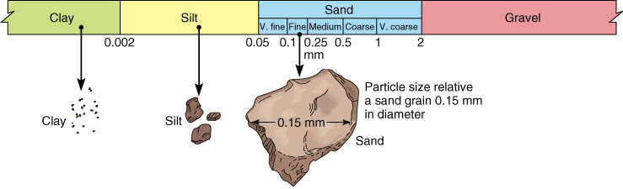

Sand: _____ - _____ mm
Silt: _____ - _____ mm
Clay: _____ mm

What type of soil has…? Find the percent of each particle at:
1. 20% clay, 40% silt, 40% sand _______________ 1. A _____% clay, _____% silt, _____% sand
2. 40% clay, 10% silt, 50% sand _______________ 2. B _____% clay, _____% silt, _____% sand
3. 30% clay, 60% silt, 10% sand _______________ 3. C _____% clay, _____% silt, _____% sand
Importance of Soil Texture

Property | Sand | Silt | Clay

Texture Review
Why is 100% sand undesirable for plants?

Why is 100% clay undesirable for plants?

Sand, Silt, or Clay?
- A soil with a lot of ______________ would have good drainage, but poor nutrient-holding characteristics.
- A soil with a lot of ______________ would have poor drainage, but good nutrient-holding characteristics.
- A soil with a lot of ______________ would have low porosity.
- A soil with a lot of ______________ would have high permeability.

Chemical Property: Acidity
Most soil pH is __________. Plants are happiest at __________.
Plants are affected by soil pH.
- The ____________________ of certain nutrient minerals varies with differences in pH
  - Low pH = _____ and _____ are more soluble, and can be absorbed in toxic amounts
  - High pH = some __________ are less soluble, and are less available to the plants
- Soil pH affects the ____________________ of nutrient minerals.
  - ____________________ = positively charged ions are less soluble and are unavailable for plants

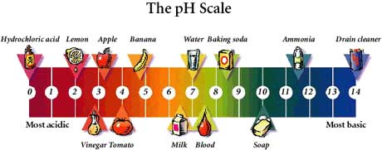

Soil Amendments
_________________________ and _________________________ are materials added to soil to improve plant growth and health by correcting the soil’s deficiencies in structure and/or nutrients

Soil Conditioner: Lime
____________________ or _______________

Important functions:
- Corrects _________________________
- Adds important plant nutrients - __________ and __________
- Reduces ____________________ and ____________________ of certain elements in the soil
  - _____, _____, _____
  - This toxicity could reduce plant growth under acid conditions
- Promotes availability of major plant nutrients.
  - _____, _____, _____
- Increases ____________________ activity and ____________________ relationships

Soil Conditioner: Compost
- Decayed ______________________________
- Replaces some _________________________
- Improves ______________________________
  - The soil becomes more _______________, increasing air circulation and the ability of the soil to ___________________________________.
  - Makes the soil more __________________.

Why is soil important?

Soil ______________________________
Soil stores ____________________________________ (_____, _____, _____, _____, and _____)
Soil ______________________________
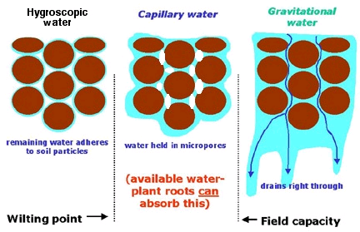

Soil provides support for ______________________________
Soil ____________________, ____________________, ____________________

Soil Pollution
Soil pollution is any physical or chemical change in soil that adversely affects the health of plants and other organisms living in and on it.
Many soil pollutants…
- ________________________________________
  - move into groundwater, surface water, or air
- ________________________________________
  - seep into tiny cracks called ____________________ and adhere to the soil particles
- ________________________________________
- ________________________________________

Salinization of Irrigated Soil
- Irrigation water soaks through the _______________ area where the plant roots grow, adding to the existing water.
- The additional irrigation water causes the underground _________________________ to rise, bringing salt to the surface.
- When the irrigated area dries and the underground water table recedes, _______________ is left on the surface soil.
- Each time the area is irrigated this ____________________ process is repeated.
- All irrigation water contains some ______________________________.

Effect of Salinized Soil on Plants
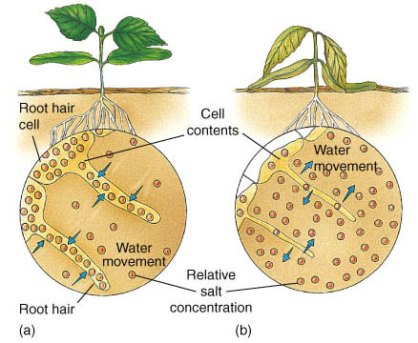

Normally, the water concentration inside plant cells is _______________ than that in the soil resulting in a net movement of water ____________________________________.

When soil contains a high amount of _______________, its relative water concentration can be _______________ than the water concentration inside cells. This causes water to move ____________________________________, even when the soil is wet.

Soil Remediation
- Until recently, the only way to remove soil contaminants was to _________________________ and _________________________
- Why is this a bad thing to do??
  - _______________, kills all beneficial organisms, creates __________, _______________

Soil Remediation Techniques
_________________________: Add lots of water; leach out pollutants
_________________________: Inject air into soil to remove volatile organic compounds
_________________________: Use microorganisms to degrade organic contaminants (oil, sludge)
_________________________: Use plants to absorb contaminants such as salts or heavy metals.

Dilution
Pollutants with low sorption potential are not attracted to soil particles and are easily _______________________
Pollutants with high sorption potential are attracted to soil particles and are NOT easily _____________________
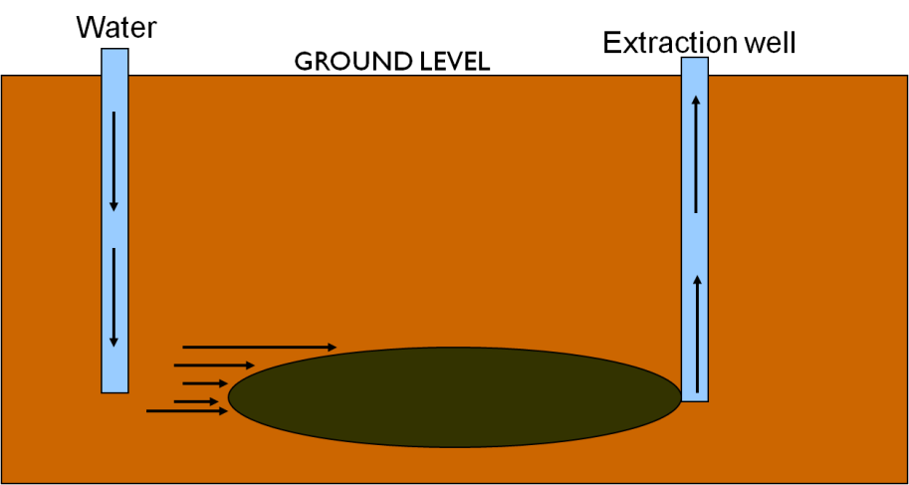

Bioremediation

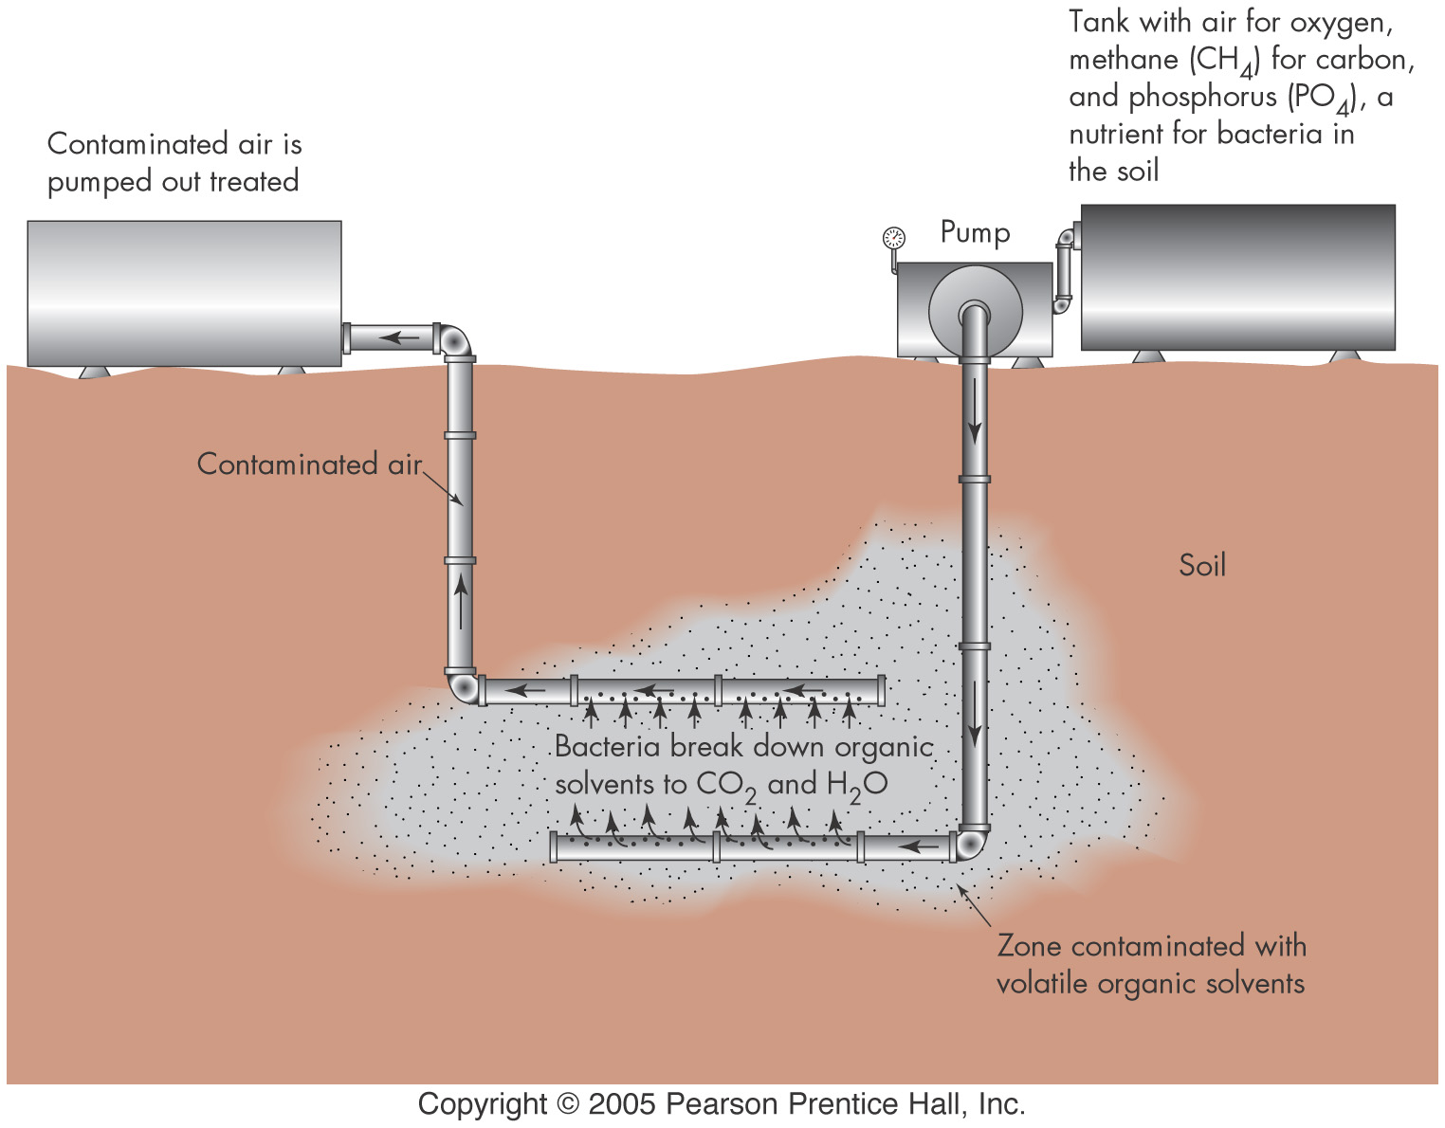

Activities that Threaten Soil
- ______________________________
- ______________________________
- ______________________________
- ______________________________
Soil Erosion
Agricultural: _____% of the world’s best agricultural land damaged due to _________________________ and ____________________ over last 50 years

Prevention
- ______________________________ We will cover this stuff in the land use unit.
- ______________________________
- ______________________________
- ______________________________

