Population Dynamics, Carrying Capacity, and Conservation Biology

Major Characteristics of a Population
Populations can change in:
1.
2.
3.
4.
Dispersion
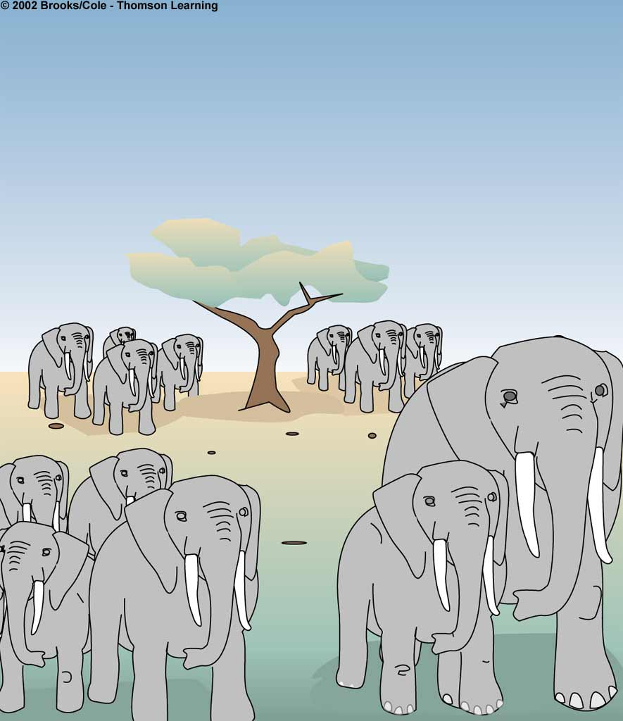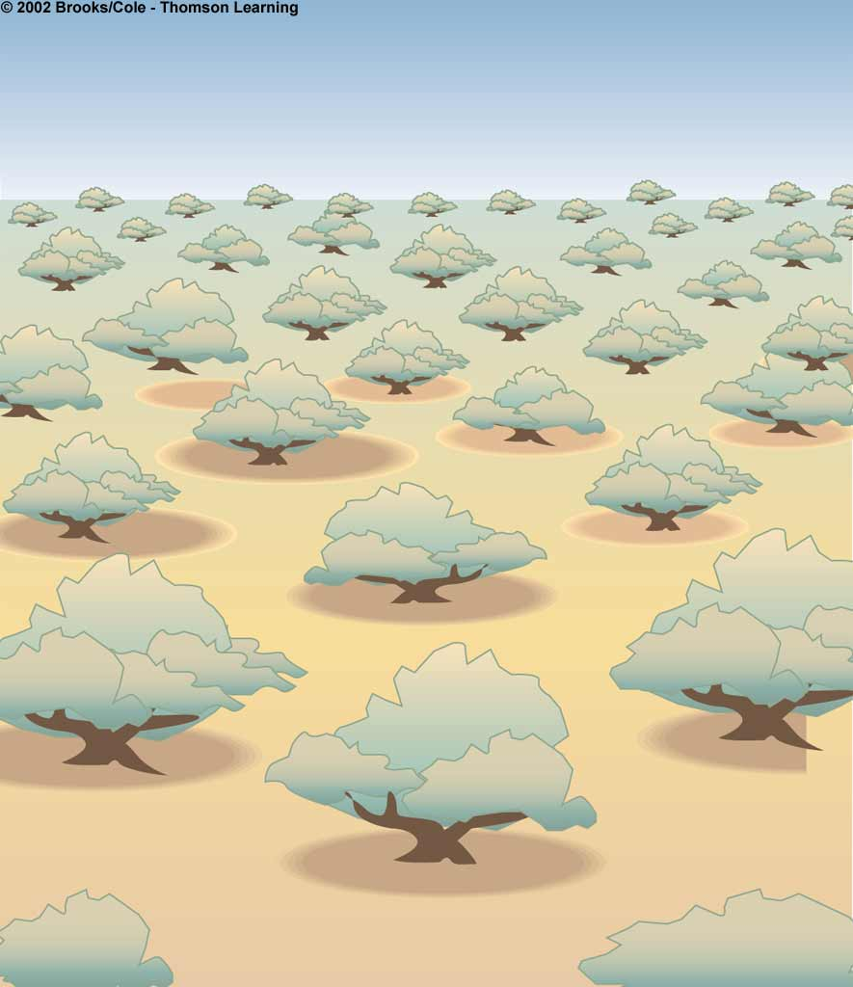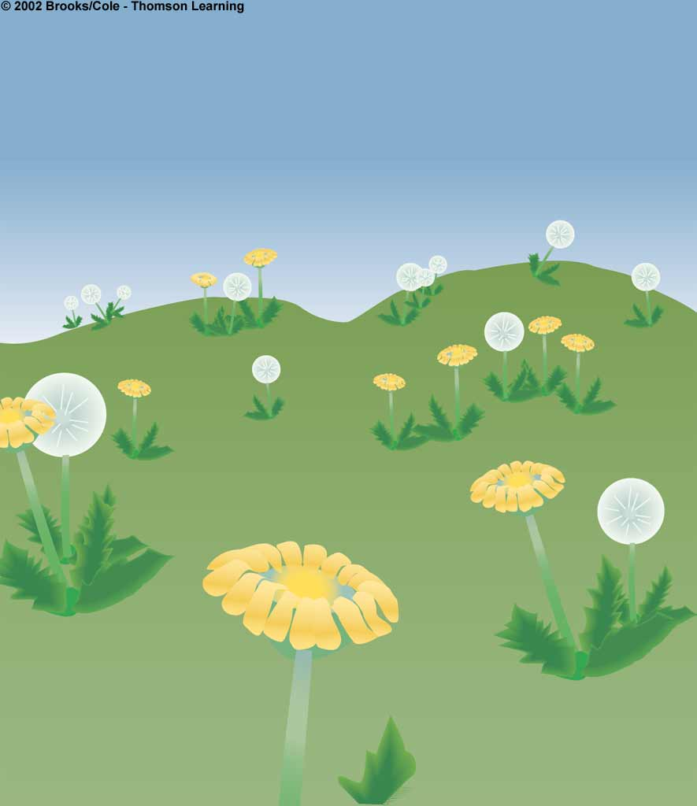

__________________ __________________ __________________

These changes are called __________________________________________.
They occur in response to ___________________________________ or changes in ________________________________.

What limits population growth?
1.
2.
3.
4.
Population growth = (_______________ + ________________) – (_________________ + __________________)

Populations vary in ______________________________________ (growth)
Intrinsic rate of increase-

Characteristics of populations with high intrinsic rates of increase
- _____________________ early in life
- Short _____________________times
- Reproduce ____________________times
- Many _______________________ each time they reproduce
Example:
But, of course, this is not ______________________ because no population can grow ______________________.
There are always ________________________ factors!

Environmental resistance includes:
Together, ________________________ and __________________________ determine the __________________________.

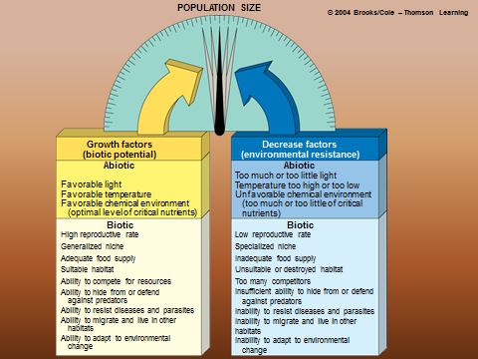

Carrying Capacity-

Minimum Viable Population-

Exponential and Logistic Growth
A population has _________________________________ growth when it has few/no resource ________________________
______-shaped curve

Logistic Growth-
______-shaped curve
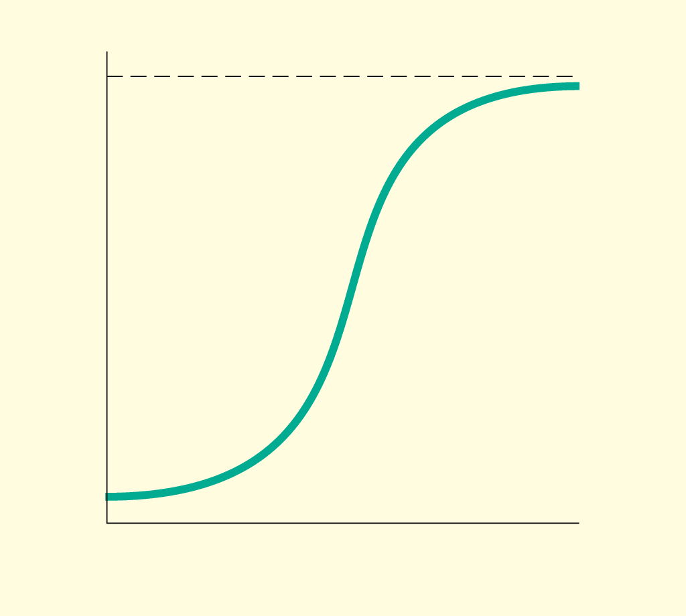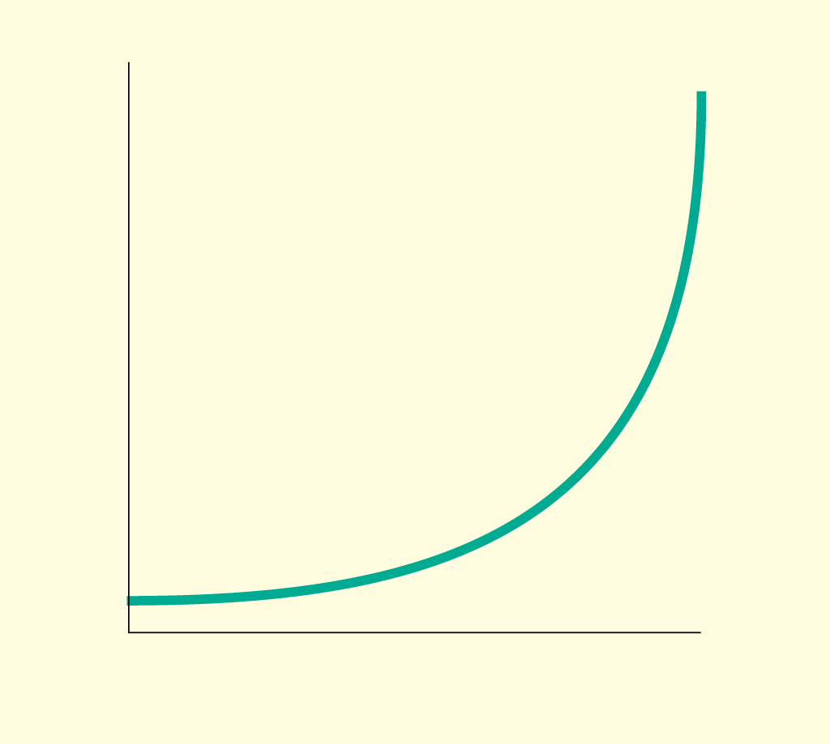

_________________________ _________________________

What Happens if Population Size Exceeds Carrying Capacity?
Overshoot-
Dieback-
__________ are not exempt from this!
Example: potato fungus in _____________________; 1 million people died/3 million __________
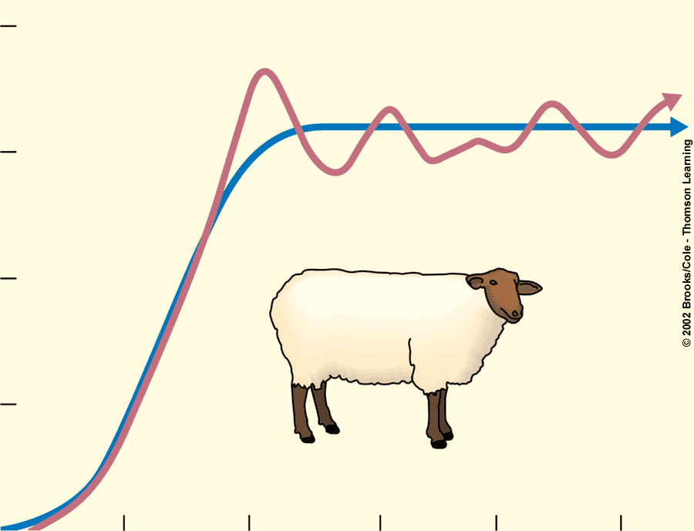
Overshoot

How Does Density Affect Population Growth?
Density-independent population controls-
Examples:
Density-depending population controls-
Examples:

Population Curves in Nature
Stable:

Irruptive:

Irregular:

Cyclic:

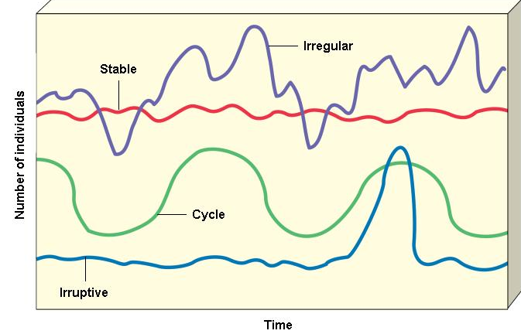

Do Predators Control Population Size?
Lynx-Hare Cycle:
_____________________ of hares reduces __________________ population
Hare population builds up because there are fewer _________________________.
Lynx population ___________ because there are more _________________________.
Cycle ______________________ again.

Two Ideas About the Lynx-Hare Cycle
- Top-down control hypothesis:

2. Bottom-up control hypothesis:

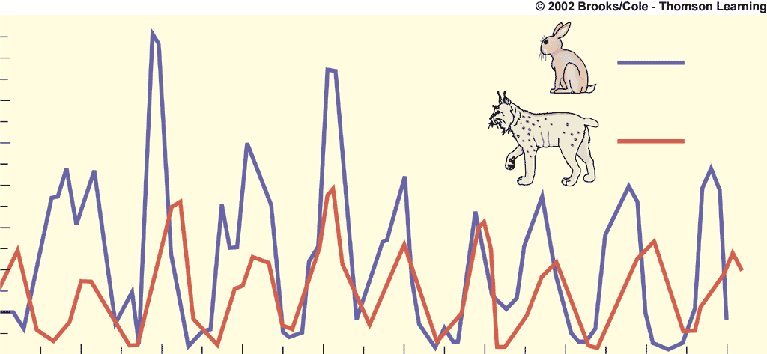

Reproductive Patterns and Survival
Asexual reproduction:

Sexual Reproduction:

r-selected Species: _____________________ species; high _______________________ rate of increase; reproduce ________________________
Examples:
    - Many _____________________ each time they reproduce
    - ______________________ at a young age
    - Short _____________________ times
    - Little or no ________________________ care
    - Short _______________________
    - ________________________ and _____________________ changes in population size
K-selected Species: ___________________________ species
Examples:
    - ________________________ late in life
    - ________________________ offspring
    - Long _________________________ times
    - ________________________ and protect their young
    - ________________________ growth curve

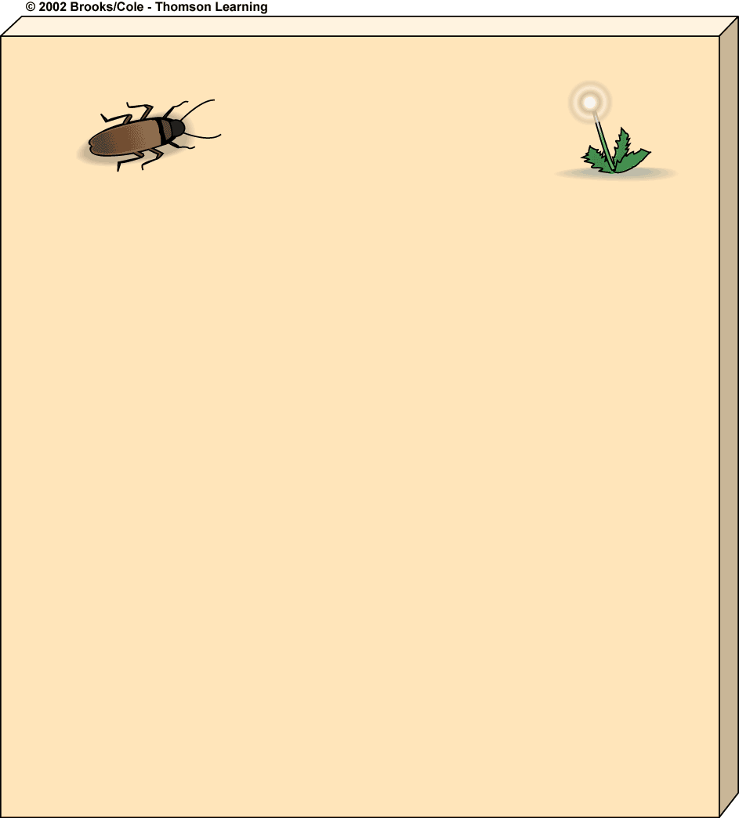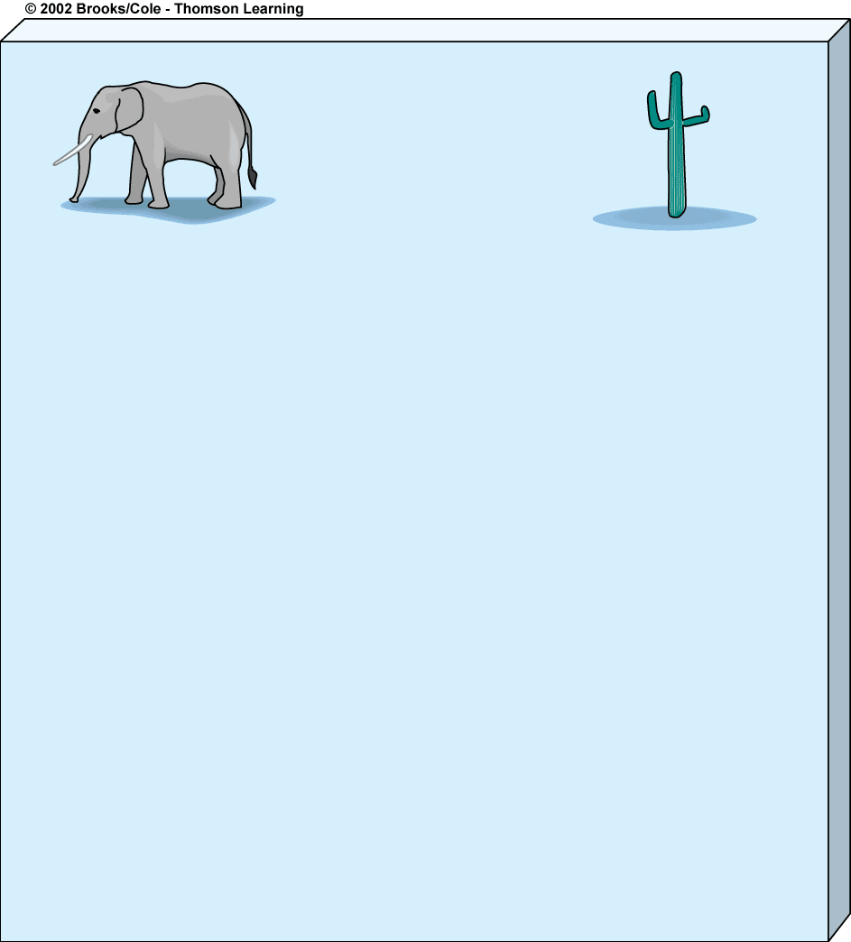
K-Selected Species
Fewer, larger offspring
High parental care and protection of offspring
Later reproductive age
Most offspring survive to reproductive age
Larger adults
Adapted to stable climate and environmental
conditions
Lower population growth rate (r)
Population size fairly stable and usually close
to carrying capacity (K)
Specialist niche
High ability to compete
Late successional species
Many small offspring
Little or no parental care and protection of offspring
Early reproductive age
Most offspring die before reaching reproductive age
Small adults
Adapted to unstable climate and environmental
conditions
High population growth rate (r)
Population size fluctuates wildly above and below
carrying capacity (K)
Generalist niche
Low ability to compete
Early successional species
r-Selected Species

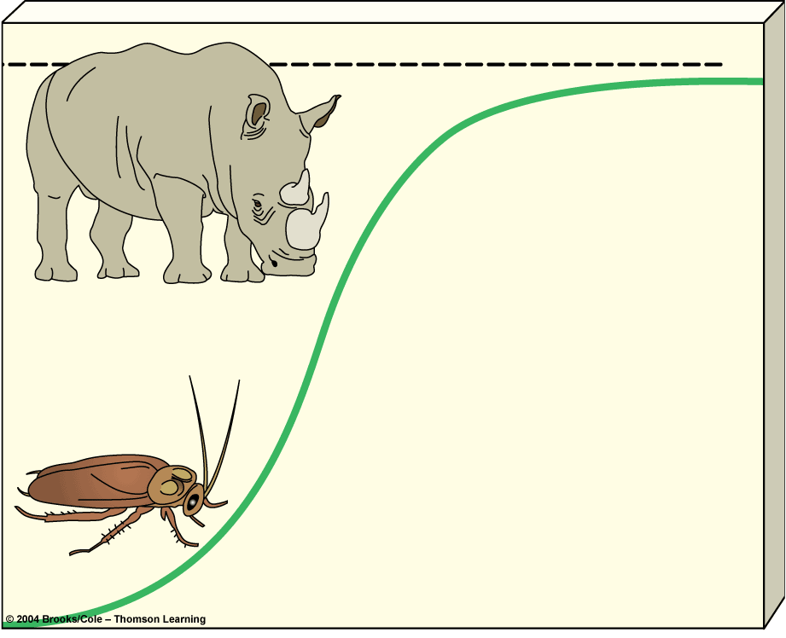
K species;
experience
K selection
r species;
experience
r selection

Survivorship Curves
Shows the number of survivors of each ____________________ for a species.
3 Types:
1. Late Loss Curves:
Example:

2. Constant Loss Curves:
Example:

3. Early Loss Curves:
Example:

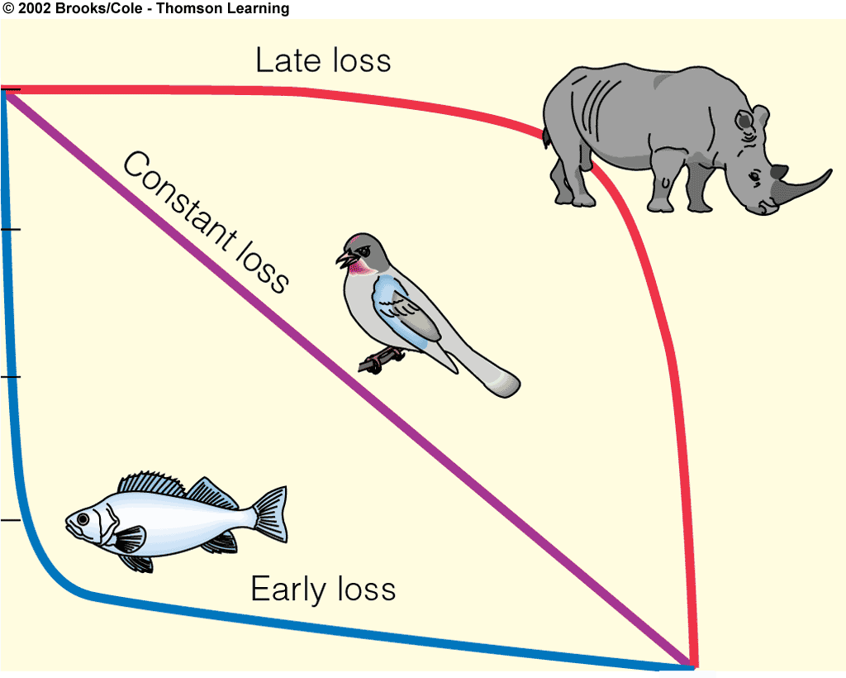

Conservation Biology
Uses science to take action to preserve __________________________ and _____________________________.
3 Principles:
- Biodiversity is necessary to all life on earth and should not be _________________by humans
- Humans should not ___________________ vital ecological processes
- The best way to preserve earth’s biodiversity is to _______________________ ecosystems

