The Solid Earth (Hippocampus – Unit 1: Chapter 3)
INTRODUCTION
The speculations of early civilizations regarding the nature of the earth were mostly based on lore and legend rather than scientific thought. But a few individuals did manage some remarkable insight. The Greek historian Herodotus, who lived during the 5th century B.C., correctly deduced that the Mediterranean Sea had once extended much farther to the south based on the discovery of fossil shells in the interior parts of Egypt and Libya. During the 3rd century B.C., the Greek mathematician Eratosthenes concluded the Earth was spherical, calculated its diameter and circumference. Yet, few people believed or could even comprehend such assertions. Misconceptions and prejudices regarding the nature of the earth came and went through the centuries. Only a little more than 500 years ago, sailors aboard Columbus' ships begged him to turn back, because they were fearful that they would fall off the edge of the earth. Until recently, most people held the traditional belief that the earth's age could be measured on the order of thousands of years, not millions or billions.
We now know that the earth is more than 4.5 billion years old, and that the surface of the earth has undergone continual change. Limestone that now comprises a mountain was once a coral reef in an ancient tropical sea hundreds of millions of years earlier. Granitic rock that now soars thousands of feet above sea level was originally formed deep in the earth's crust. Water and wind erode the rocky faces of mountains and carry away the bits of rock to accumulate as sediments in a lake or ocean. The sediments become buried and compacted and form new rocks, which in turn form new mountains and complete the natural cycle. Scientists use their knowledge of how rocks form and change and how old they are in order to deveop a comprehensive understanding of the earth and its geologic history.
EARTH'S FORMATION AND STRUCTURE
The earth formed approximately 4.6 billion years ago from a nebular cloud of dust and gas that surrounded the sun. As the gas cooled, more solids formed. The dusty material accreted to the nebular midplane where it formed progressively larger clumps. Eventually, bodies of several kilometers in diameter formed; these are known as planetesimals. The largest planetesimals grew fastest, at the expense of the smaller ones. This process continued until an earth-sized planet had formed.
Early in its formation, the earth must have been completely molten. The main source of heat at that time was probably the decay of naturally-occurring radioactive elements. As the earth cooled, density differences between the forming minerals caused the interior to become differentiated into three concentric zones: the crust, mantle and core. The crust extends downward from the surface to an average depth of 35 km where the mantle begins. The mantle extends down to a depth of 2900 km where the core begins. The core extends down to the center of the earth, a depth of about 6400 km from the surface.
The core makes up 16 percent of the volume of the earth and about 31 percent of the mass. It can be divided into two regions: a solid inner core and a liquid outer core. The inner core is probably mostly metallic iron alloyed with a small amount of nickel, as its density is somewhat greater than that of pure metallic iron. The outer core is similar in composition, but probably also contains small amounts of lighter elements, such as sulfur and oxygen, because its density is slightly less than that of pure metallic iron. The presence of the lighter elements depresses the freezing point and is probably responsible for the outer core's liquid state.
The mantle is the largest layer in the earth, making up about 82 percent of the volume and 68 percent of the mass of the earth. The mantle is dominated by magnesium and iron-rich (mafic) minerals. Heat from the core of the earth is transported to the crustal region by large-scale convection in the mantle.
Near the top of the mantle is a region of partially melted rock called the asthenosphere. Numerous small-scale convection currents occur here as hot magma (i.e., molten rock) rises and cooler magma sinks due to differences in density.
The crust is the thinnest layer in the earth, making up only 1 percent of the mass and 2 percent of the volume. Relative to the rest of the earth, the crust is rich in elements such as silicon, aluminum, calcium, sodium and potassium. Crustal materials are very diverse, consisting of more than 2000 minerals. The less dense crust floats upon the mantle in two forms: the continental crust and the oceanic crust. The oceanic crust, which contains more mafic minerals is thinner and denser than the continental crust which contains minerals richer in silicon and aluminum. The thick continental crust has deep buoyant roots that help to support the higher elevations above. The crust contains the mineral resources and the fossil fuels used by humans.
GEOLOGIC TIME SCALE
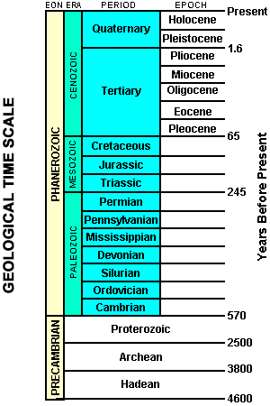
The Earth is more than 4.5 billion years old and such a large interval of time can be difficult for the average person to comprehend. Although there is not a direct record of most of this past geologic time, earth scientists have indirect evidence of what took place in the past in the record of the earth's rocks. Some of these rock records are lost and others are jumbled, but many remain, providing accounts of the astonishing events that have taken place in the life of the earth. Geologists can reconstruct these events by combining studies on the origins of rocks (petrology) and rock layering (stratigraphy) with the evolution of life (paleontology). Using key fossils found in rock layers as markers, scientists can identify rocks of the same age throughout the world. From these studies, a relative geologic time scale based on the sequence of rock layering was established.

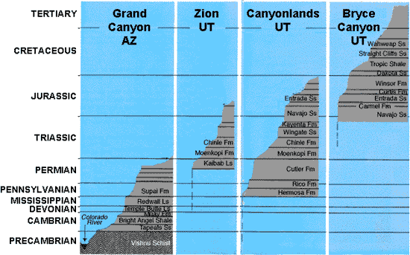

This geologic time scale consists of segments of time represented by recurring geologic events such as mountain building and sea level changes. Geologists have used these time segments to divide the earth's history into broad time spans known as Eons and Eras and shorter spans known as Periods and Epochs. Major discontinuities in the geologic and fossil records are chosen as boundary lines between the different time segments. For example, the boundary between the Cretaceous Tertiary periods marks a sudden mass extinction of species the included the dinosaurs. More recently, a radiometric time scale, based on the natural radioactivity of the chemical elements in rocks, has been developed through the use of modern quantitative experimental techniques. Using these techniques, absolute ages can be assigned to some parts of the geologic time scale. For example the Cretaceous-Tertiary boundary represents a time approximately 65 million years ago.

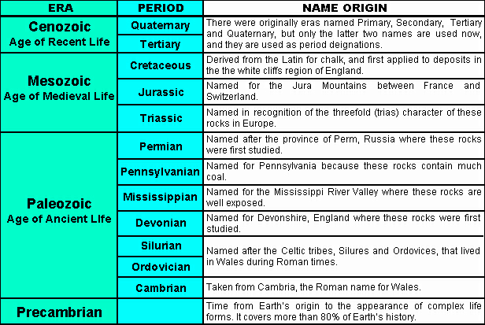

THE LITHOSPERE AND PLATE TECTONICS
The layer of the mantle above the asthenosphere plus the entire crust make up a region called the lithosphere. The lithosphere, and therefore, the earth's crust, is not a continuous shell, but is broken into a series of plates that independently "float" upon the asthenosphere, much like a raft on the ocean. These plates are in constant motion, typically moving a few centimeters a year, and are driven by convection in the mantle. The scientific theory that describes this phenomenon is called plate tectonics. According to the theory of plate tectonics, the lithosphere is comprised of some seven major plates and several smaller ones. Because these plates are in constant motion, interactions occur where plate boundaries meet.
A convergent (colliding) plate boundary occurs when two plates collide. If the convergent boundary involves two continental plates, the crust is compressed into high mountain ranges such as the Himalayas. If an oceanic plate and a continental plate collide, the oceanic crust (because it is more dense) is subducted under the continental crust.
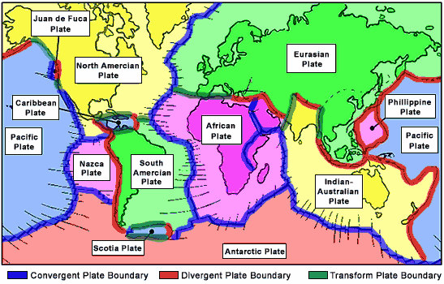
The region where subduction takes place is called a subduction zone and usually results in a deep ocean trench such as the "Mariana Trench" in the western Pacific ocean. The subducted crust melts and the resultant magma can rise to the surface and form a volcano. A divergent plate boundary occurs when two plates move away from each other. Magma upwelling from the mantle region is forced through the resulting cracks, forming new crust. The mid-ocean ridge in the Atlantic ocean is a region where new crustal material continually forms as plates diverge. Volcanoes can also occur at divergent boundaries. The island of Iceland is an example of such an occurrence. A third type of plate boundary is the transform boundary. This occurs when two plates slide past one another. This interaction can build up strain in the adjacent crustal regions, resulting in earthquakes when the strain is released. The San Andreas Fault in California is an example of a transform plate boundary.
GEOLOGICAL DISTURBANCES
VOLCANOES
An active volcano occurs when magma (molten rock) reaches the earth's surface through a crack or vent in the crust. Volcanic activity can involve the extrusion of lava on the surface, the ejection of solid rock and ash, and the release of water vapor or gas (carbon dioxide or sulfur dioxide). Volcanoes commonly occur near plate boundaries where the motion of the plates has created cracks in the lithosphere through which the magma can flow. About eighty percent of volcanoes occur at convergent plate boundaries where subducted material melts and rises through cracks in the crust. The Cascade Range was formed in this way.
Volcanoes can be classified according to the type and form of their ejecta. The basic types are: composite volcanoes, shield volcanoes, lava domes, and cinder cones. Composite volcanoes are steep-sided, symmetrical cones built of multiple layers of viscous lava and ash.
Most composite volcanoes have a crater at the summit which contains the central vent. Lavas flow from breaks in the crater wall or from cracks on the flanks of the cone. Mt Fuji in Japan and Mt Ranier in Washington are examples of composite volcanoes.
Shield volcanoes are built almost entirely of highly fluid (low viscosity) lava flows. They form slowly from numerous flows that spread out over a wide area from a central vent. The resultant structure is a broad, gently sloping cone with a profile like a warrior's shield. Mt Kilauea in Hawaii is an example of a shield volcano.
Cinder cones are the simplest type of volcano. They form when lava blown violently into the area breaks into small fragments that solidify and fall as cinders. A steep-sided cone shape is formed around the vent, with a crater at the summit. Sunset Crater in Arizona is a cinder cone that formed less than a thousand years ago, disrupting the lives of the native inhabitants of the region.
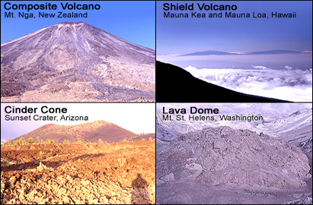
Lava domes are formed when highly viscous lava is extruded from a vent and forms a rounded, steep-sided dome. The lava piles up around and on the vent instead of flowing away, mostly growing by expansion from within. Lava domes commonly occur within the craters or on the flanks of composite volcanoes.
EARTHQUAKES
An earthquake occurs when built up strain in a mass of rock causes it to rupture suddenly. The region where the rupture occurs is called the focus. This is often deep below the surface of the crust. The point on the surface directly above the focus is called the epicenter. Destructive waves propagate outward from the region of the quake, traveling throughout the earth. The magnitude of an earthquake is a measure of the total amount of energy released.
The first step in determining the magnitude is to measure the propagated waves using a device called a seismograph. Based on this information, the earthquake is given a number classification on a modified Richter scale. The scale is logarithmic, so a difference of one unit means a difference of ten-fold in wave intensity, which corresponds to an energy difference of 32-fold. The intensity of an earthquake is an indicator of the effect of an earthquake at a particular locale. The effect depends not only on the magnitude of the earthquake, but also the types of subsurface materials and the structure and design of surface structures.
Earthquakes generally occur along breaks in the rock mass known as faults, and most occur in regions near plate boundaries. Some 80 percent of all earthquakes occur near convergent plate boundaries, triggered by the interaction of the plates. Earthquakes are also often associated with volcanic activity due to the movement of sub-surface magma. When an earthquake occurs under the ocean, it can trigger a destructive tidal wave known as a tsunami.
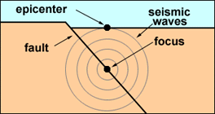
Components of an Earthquake
ROCKS AND THE ROCK CYCLE
The earth's crust is composed of many kinds of rocks, each of which is made up of one or more minerals. Rocks can be classified into three basic groups: igneous, sedimentary, and metamorphic. Igneous rocks are the most common rock type found in the earth's crust. They form when magma cools and crystallizes subsurface (intrusive igneous rocks) or lava cools and crystallizes on the surface (extrusive igneous rocks). Granite is an example of an intrusive igneous rock, whereas basalt is an extrusive igneous rock.
Sedimentary rocks are formed by the consolidation of the weathered fragments of pre-existing rocks, by the precipitation of minerals from solution, or by compaction of the remains of living organisms. The processes involving weathered rock fragments include erosion and transport by wind, water or ice, followed by deposition as sediments. As the sediments accumulate over time, those at the bottom are compacted. They are cemented by minerals precipitated from solution and become rocks.
The process of compaction and cementation is known as lithification. Some common types of sedimentary rocks are limestone, shale, and sandstone. Gypsum represents a sedimentary rock precipitated from solution. Fossil fuels such as coal and oil shale are sedimentary rocks formed from organic matter.
Metamorphic rocks are formed when solid igneous, sedimentary or metamorphic rocks change in response to elevated temperature and pressure and/or chemically active fluids. This alteration usually occurs subsurface. It may involve a change in texture (recrystallization), a change in mineralogy or both. Marble is a metamorphosed form of limestone, while slate is transformed shale. Anthracite is a metamorphic form of coal.
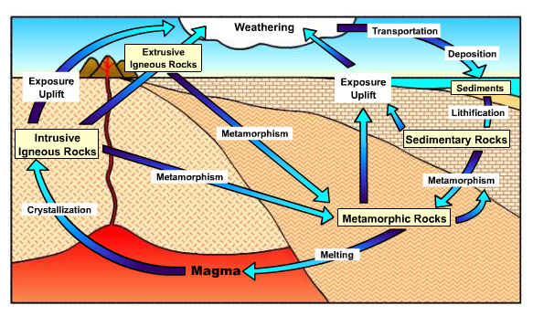
The rock cycle illustrates connections between the earth's internal and external processes and how the three basic rock groups are related to one another. Internal processes include melting and metamorphism due to elevated temperature and pressure. Convective currents in the mantle keep the crust in constant motion (plate tectonics). Buried rocks are brought to the surface (uplift), and surface rocks and sediments are transported to the upper mantle region (subduction).
Two important external processes in the rock cycle are weathering and erosion. Weathering is the process by which rock materials are broken down into smaller pieces and/or chemically changed. Once rock materials are broken down into smaller pieces, they can be transported elsewhere in a process called erosion. The main vehicle of erosion is moving water, but wind and glaciers can also erode rock.
SOIL FORMATION
Soil is one of the earth's most precious and delicate resources. Its formation involves the weathering of parent materials (e.g., rocks) and biological activity. Soil has four principal components: water, eroded inorganic parent material, air, and organic matter (e.g., living and decaying organisms).
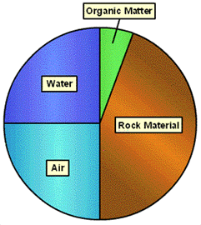
Components of Soil
Soil formation begins with unconsolidated materials that are the products of weathering. These materials may be transported to the location of soil formation by processes such as wind or water, or may result from the weathering of underlying bedrock. The weathering process involves the disintegration and decomposition of the rock. It can be physical (e.g., water seeping into rock cracks and then freezing) or chemical (e.g., dissolution of minerals by acid rain). Physical processes are more prevalent in cold and dry climates, while chemical processes are more prevalent in warm or moist climates.
Soil materials tend to move vertically in the formation environment. Organic materials (e.g., leaf litter) and sediments can be added, while other materials (e.g., minerals) can be lost due to erosion and leaching. Living organisms (e.g., bacteria, fungi, worms, and insects) also become incorporated into the developing soil.
The living component of the soil breaks down other organic materials to release their nutrients (e.g., nitrogen, potassium and phosphorous). The nutrients are then used and recycled by growing plants and other organisms. This recycling of nutrients helps create and maintain a viable soil.
Several factors influence soil formation including: climate, parent material, biologic organisms, topography and time. The climate of an area (precipitation and temperature) may be the most important factor in soil formation. Temperature affects the rates of chemical reactions and rainfall affects soil pH and leaching. Parent material or bedrock varies from region to region and can affect the texture and pH of soils. Vegetation type affects the rate at which nutrients in the soil are recycled, the type and amount of organic matter in the soil, soil erosion, and the types and numbers of micro-organisms living in the soil.
Humans can also have a profound effect on soils through such activities as plowing, irrigating and mining. The topography of a region affects rainfall runoff, erosion and solar energy intake. Soil formation is a continuous process. Soils change with time as factors such as organic matter input and mineral content change. The process of making a soil suitable for use by humans can take tens of thousands of years. Unfortunately, the destruction of that soil can occur in a few short generations.

Soils (Hippocampus – Unit 3: Chapter 11)
INTRODUCTION
Soil plays an important role in land ecosystems. In order for a community of producers and consumers to become established on land, soil must be present. Furthermore, soil quality is often a limiting factor for population growth in ecosystems. Soil is a complex mixture of inorganic materials, organic materials, microorganisms, water and air. Its formation begins with the weathering of bedrock or the transport of sediments from another area. These small grains of rock accumulate on the surface of the earth. There they are mixed with organic matter called humus, which results from the decomposition of the waste and dead tissue of organisms. Infiltrating rainwater and air also contribute to the mixture and become trapped in pore spaces. This formation process is very slow (hundreds to thousands of years), and thus soil loss or degradation can be very detrimental to a community.
SOIL PROFILE
Mature soils are layered. These layers are known as soil horizons, and each has a distinct texture and composition. A typical soil has a soil profile consisting of four horizons, which are designated: O, A, B and C. The O horizon is the top layer at the earth's surface. It consists of surface litter, such as fallen leaves (duff), sticks and other plant material, animal waste and dead organisms. A distinct O horizon may not exist in all soil environments (e.g., desert soil). Below the O horizon is the A horizon, which is also known as topsoil. This layer contains organic humus, which usually gives it a distinctive dark color. The B horizon, or sub-soil is the next layer down from the surface. It consists mostly of inorganic rock materials such as sand, silt and clay. The C horizon sits atop bedrock and therefore is made up of weathered rock fragments. The bedrock is the source of the parent inorganic materials found in the soil.
The O horizon protects the underlying topsoil from erosion and moisture loss by evaporation. The O and A horizons in typical mature soils have an abundance of microorganisms (e.g. fungi, bacteria), earthworms and insects. These organisms decompose the organic material from dead organisms and animal waste into inorganic nutrients useable by plants. The organic humus in the A horizon aids in holding water and nutrients, making it the most fertile layer. Therefore, plants with shallow roots are anchored in the A horizon. Water seeping through the upper layers may dissolve water-soluble minerals and transport them to lower layers in a process called leaching. Very fine clay particles can also be transported by seeping water and accumulate in the subsoil layer. The accumulation of clay particles and leached minerals can lead to compaction of the B horizon. This compaction can limit the flow of water through the layer and cause the soil above to become waterlogged.
The B horizon is not as fertile as the A horizon, but deep-rooted plants can utilize the water and minerals leached into this layer. The C horizon represents a transition zone between the bedrock and the soil. It lacks organic material, but may be saturated with groundwater that is unable to move deeper due to the solid barrier of bedrock below.
Different types of soil may have different numbers of horizons, and the composition and thickness of those horizons may vary from soil to soil. The type of soil depends on a number of factors including: the type of parent rock material, the type of vegetation, the availability of organic matter, water and minerals, and the climate. Grassland and desert soils lack a significant O horizon as they generally have no leaf litter. Grassland soil may have a very thick, fertile A horizon, while desert and tropical rain forest soils may have very thin, nutrient poor A horizons. The A horizons in coniferous forests may be severely leached.
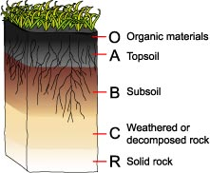
SOIL CHARACTERISTICS
Most soil consists of weathered inorganic rock material. The relative amounts of different sizes and types of rock particles or grains determines the texture of the soil. The three main types of rock grains found in soil are: sand, silt and clay. Sand grains have the largest grain sizes (0.05 - 2.0 mm) of the three. Silt particles are fine-grained (0.05-0.002 mm) and clay particles are very fine-grained (<0.002 mm). Sand grains give soil its gritty feel, and clay particles make it sticky. Soils are named according to where their sand silt and clay composition plots on a soil structure triangle. Various regions of the triangle are given different names. A soil containing about 20:40:40 mixture of clay, silt and sand plot A typical loam soil is made up of about a 20:40:40 mixture of clay, silt and sand. If the percentage of sand is a little higher, the soil is called a sandy loam, and if the percentage of silt is a little higher the soil is a silty loam.
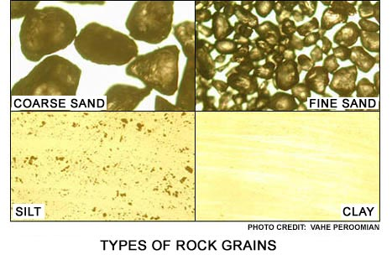
The texture of the soil determines its porosity and permeability. Soil porosity is a measure of the volume of pore spaces between soil grains per volume of soil and determines the water and air (oxygen) holding capacity of the soil. Coarse grains with large pores provide better aeration and fine grains with small pores provide good water retention.
The average pore size determines the soil permeability or ease with which water can infiltrate the soil. Sandy soils have low porosities and high permeabilities (i.e. water is not retained well, but flows through them easily, and aeration is good). On the other hand, clay soils have high porosities and low permeabilities (i.e. water is retained very well, but does not flow through it easily and aeration is poor). Soil texture is therefore important in determining what type of vegetation thrives on a particular soil.
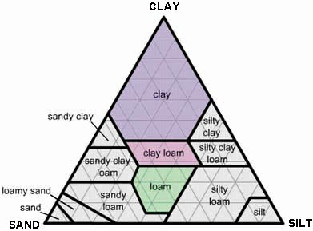
The soil structure or "tilth" is related to the soil texture. Soil tilth describes how the various components of the soil cling together into clumps. It is determined by the amount of clay and humus in the soil. The physical and chemical properties of clay and humus enable them to adhere to other particles in the soil, thus forming large aggregates. These same properties also help protect the soil from nutrient leaching. Soils lacking clay and humus are very loose and are easily blown or shifted by the wind (i.e. sand dunes in the desert).
SOIL FERTILITY AND pH
There are 16 elements essential for plant growth. Plants obtain three of them primarily from air and water: carbon, hydrogen and oxygen. The other 13 elements generally come from the soil. These essential elements for plant growth can be grouped into three types: primary macronutrients (nitrogen, potassium, phosphorus), secondary macronutrients (calcium, magnesium, sulfur) and micronutrients (boron, chlorine, iron, manganese, copper, zinc, molybdenum). The available primary macronutrients in the soil are usually the limiting factor in plant growth. In undisturbed soils, these macronutrients are replenished by the natural cycles of matter. In farmed soils, they are removed from the natural cycle in such large amounts when crops are harvested that they usually must be replaced by supplementary means (e.g. fertilizer). Because micronutrients are required by plants in much lower quantities, they are often naturally maintained in the soil in sufficient quantities to make supplementation with fertilizers unnecessary.
An important factor affecting soil fertility is soil pH (the negative log of the hydrogen ion concentration). Soil pH is a measure of the acidity or alkalinity of the soil solution. On the pH scale (0 to 14) a value of seven represents a neutral solution, a value less than seven represents an acidic solution and a value greater than seven represents an alkaline solution. Soil pH affects the health of microorganisms in the soil and controls the availability of nutrients in the soil solution. Strongly acidic soils (less than 5.5) hinder the growth of bacteria that decompose organic matter in the soil. This results in a buildup of undecomposed organic matter, which leaves important nutrients such as nitrogen in forms that are unusable by plants.
Soil pH also affects the solubility of nutrient-bearing minerals. This is important because the nutrients must be dissolved in solution for plants to assimilate them through their roots. Most minerals are more soluble in slightly acidic soils than in neutral or slightly alkaline soils.
Strongly acid soils (pH four to five), though, can result in high concentrations of aluminum, iron and manganese in the soil solution, which may inhibit the growth of some plants. Other plants, however, such as blueberries, thrive in strongly acidic soil. At high pH (greater than 8.5) many micronutrients such as copper and iron become limited. Phosphorus becomes limited at both low and high pH. A soil pH range of approximately six to eight is conducive to the growth of most plants.
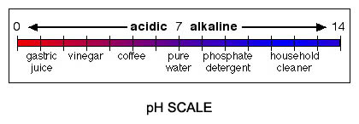
SOIL DEGRADATION
Soil can take hundreds or thousands of years to mature. Therefore, once fertile topsoil is lost, it is not easily replaced. Soil degradation refers to deterioration in the quality of the soil and the concomitant reduction in its capacity to produce. Soils are degraded primarily by erosion, organic matter loss, nutrient loss and salinization. Such processes often arise from poor soil management during agricultural activities. In extreme cases, soil degradation can lead to desertification (conversion of land to desert-like conditions) of croplands and rangelands in semi-arid regions.
Erosion is the biggest cause of soil degradation. Soil productivity is reduced as a result of losses of nutrients, water storage capacity and organic matter. The two agents of erosion are wind and water, which act to remove the finer particles from the soil. This leads to soil compaction and poor soil tilth. Human activities such as construction, logging, and off-road vehicle use promote erosion by removing the natural vegetation cover protecting the soil.
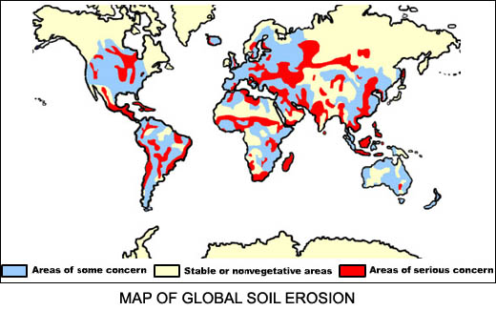
Agricultural practices such as overgrazing and leaving plowed fields bare for extended periods contribute to farmland erosion. Each year, an estimated two billion metric tons of soil are eroded from farmlands in the United States alone. The soil transported by the erosion processes can also create problems elsewhere (e.g. by clogging waterways and filling ditches and low-lying land areas).
Wind erosion occurs mostly in flat, dry areas and moist, sandy areas along bodies of water. Wind not only removes soil, but also dries and degrades the soil structure. During the 1930s, poor cultivation and grazing practices -- coupled with severe drought conditions -- led to severe wind erosion of soil in a region of the Great Plains that became known as the "Dust Bowl." Wind stripped large areas of farmlands of topsoil, and formed clouds of dust that traveled as far as the eastern United States.
When considerable quantities of salt accumulate in the soil in a process known as salinization, many plants are unable to grow properly or even survive. This is especially a problem in irrigated farmland.
Water erosion is the most prevalent type of erosion. It occurs in several forms: rain splash erosion, sheet erosion, rill erosion and gully erosion. Rain splash erosion occurs when the force of individual raindrops hitting uncovered ground splashes soil particles into the air. These detached particles are more easily transported and can be further splashed down slope, causing deterioration of the soil structure. Sheet erosion occurs when water moves down slope as a thin film and removes a uniform layer of soil. Rill erosion is the most common form of water erosion and often develops from sheet erosion. Soil is removed as water flows through little streamlets across the land. Gully erosion occurs when rills enlarge and flow together, forming a deep gully.
Groundwater used for irrigation contains small amounts of dissolved salts. Irrigation water that is not absorbed into the soil evaporates, leaving the salts behind. This process repeats itself and eventually severe salinization of the soil occurs. A related problem is waterlogging of the soil. When cropland is irrigated with excessive amounts of water in order to leach salts that have accumulated in the soil, the excess water is sometimes unable to drain away properly. In this case it accumulates underground and causes a rise in the subsurface water table. If the saline water rises to the level of the plant roots, plant growth is inhibited.
SOIL CONSERVATION
Because soil degradation is often caused by human activity, soil conservation usually requires changes in those activities. Soil conservation is very important to agriculture, so various conservation methods have been devised to halt or minimize soil degradation during farming. These methods include: construction of windbreaks, no-till farming, contour farming, terracing, strip cropping and agroforestry.
Creating windbreaks by planting tall trees along the perimeter of farm fields can help control the effects of wind erosion. Windbreaks reduce wind speed at ground level, an important factor in wind erosion. They also help trap snow in the winter months, leaving soil less exposed. As a side benefit, windbreaks also provide a habitat for birds and animals. One drawback is that windbreaks can be costly to farmers because they reduce the amount of available cropland.
One of the easiest ways to prevent wind and water erosion of croplands is to minimize the amount of tillage, or turning over of the soil. In no-till agriculture (also called conservation tillage), the land is disturbed as little as possible by leaving crop residue in the fields. Special seed drills inject new seeds and fertilizer into the unplowed soil. A drawback of this method is that the crop residue can serve as a good habitat for insect pests and plant diseases.
Contour farming involves plowing and planting crop rows along the natural contours of gently sloping land. The lines of crop rows perpendicular to the slope help to slow water runoff and thus inhibit the formation of rills and gullies. Terracing is a common technique used to control water erosion on more steeply sloped hills and mountains. Broad, level terraces are constructed along the contours of the slopes, and these act as dams trapping water for crops and reducing runoff.
Strip cropping involves the planting of different crops on alternating strips of land. One crop is usually a row crop such as corn, while the other is a ground-covering crop such as alfalfa. The cover crop helps reduce water runoff and traps soil eroded from the row crop. If the cover crop is a nitrogen-fixing plant (e.g. alfalfa, soybeans), then alternating the strips from one planting to the next can also help maintain topsoil fertility.
Agroforestry is the process of planting rows of trees interspersed with a cash crop. Besides helping to prevent wind and water erosion of the soil, the trees provide shade which helps promote soil moisture retention. Decaying tree litter also provides some nutrients for the interplanted crops. The trees themselves may provide a cash crop. For example, fruit or nut trees may be planted with a grain crop.

